

FAKULTI TEKNOLOGI MAKLUMAT DAN KOMUNIKASI (FTMK)

BTMW 4012 TECHNOLOGY ENTREPRENEURSHIP

SEMESTER II

SESSION 2021/2022

BUSINESS SALES REPORT

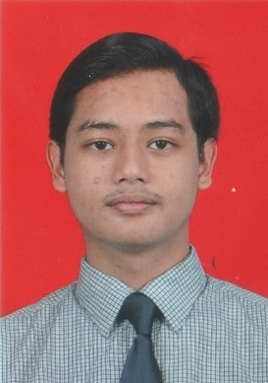

Muhammad Izham Bin Norhamadi

B032020039

3 BITZ

PREPARED FOR: ISMAIL BIN IBRAHIM

## Personal Information

|  |  |
| --- | --- |
| Name | Muhammad Izham Bin Norhamadi |
| Gender | Male |
| Age | 22 |
| Race | Malay |
| Matric No | B032020039 |
| Course | Bachelor of Computer Science (Computer Security) (BITZ) |
| Email address | B032020039@student.utem.edu.my |

## Product Description

Steam Digital Wallet cards work just like gift certificates, which can be redeemed on Steam for the purchase of games, software, and any other item to be purchased on Steam. The cost of the service is RM0.50.

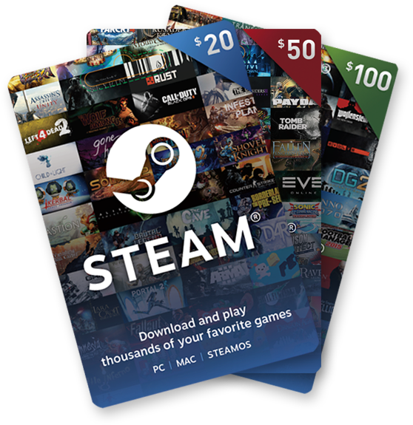

## Product Images

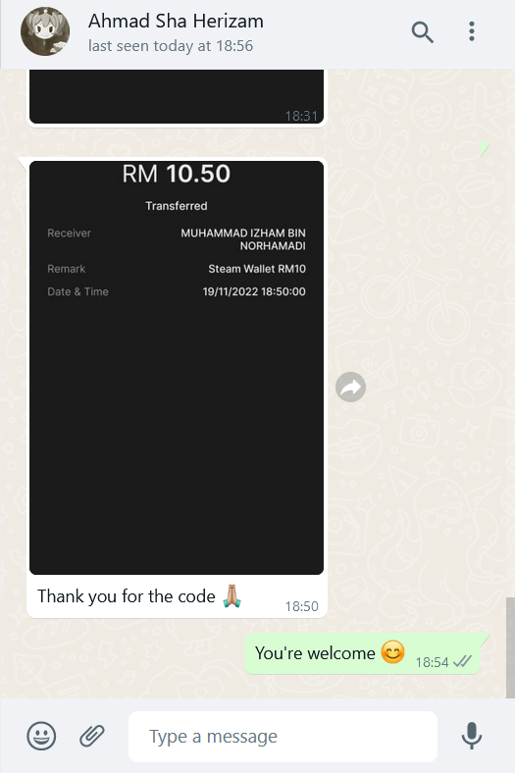

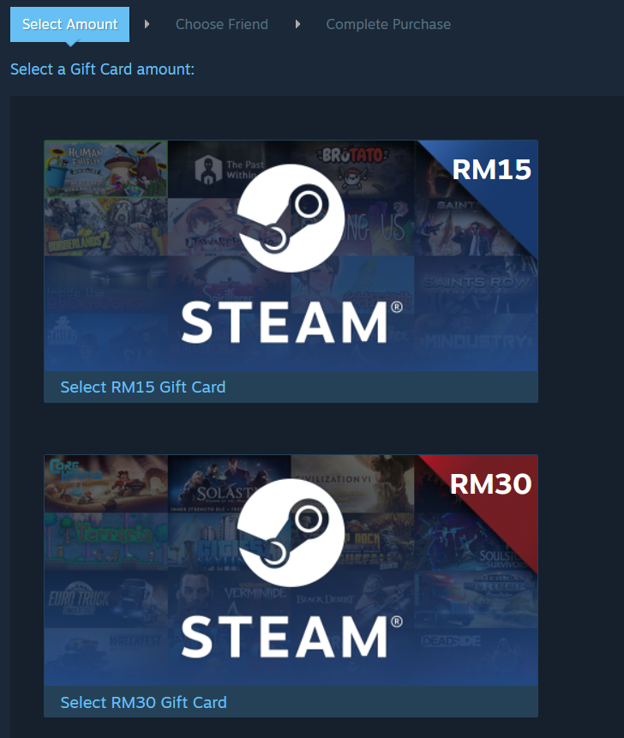

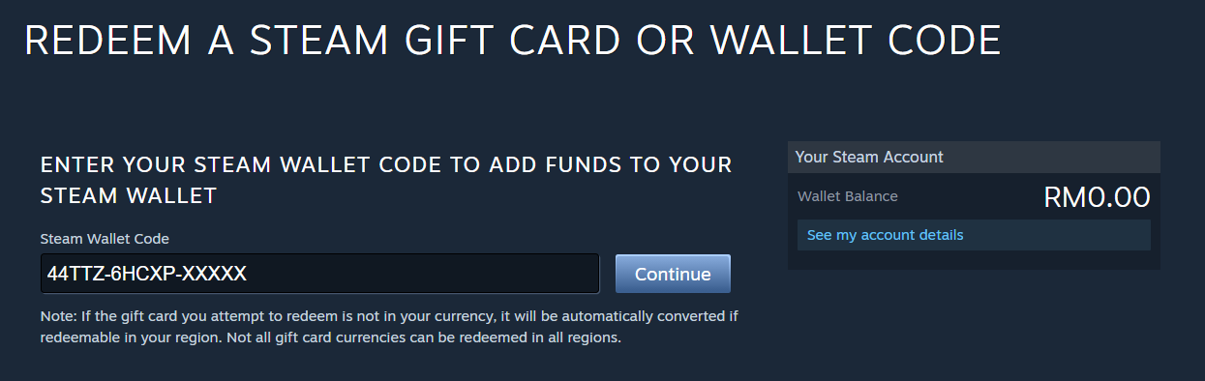

## Customer’s Payment Receipt

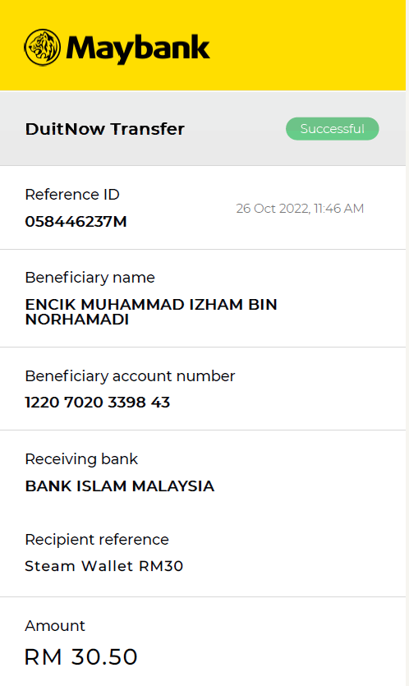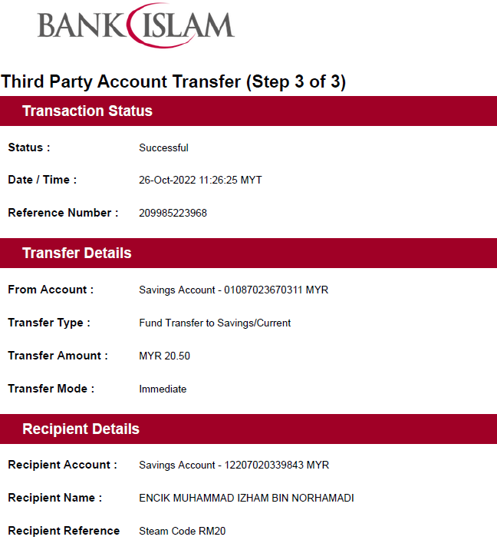

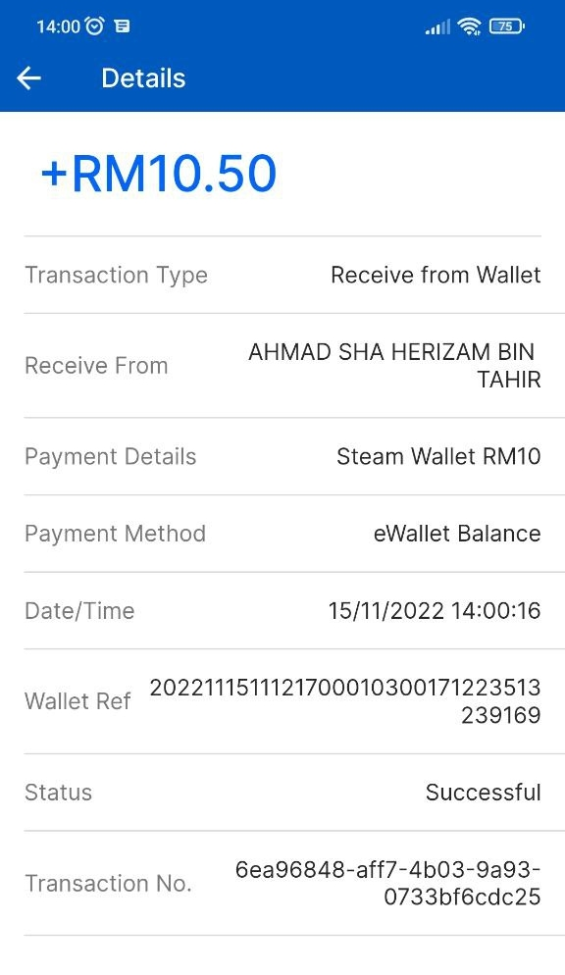

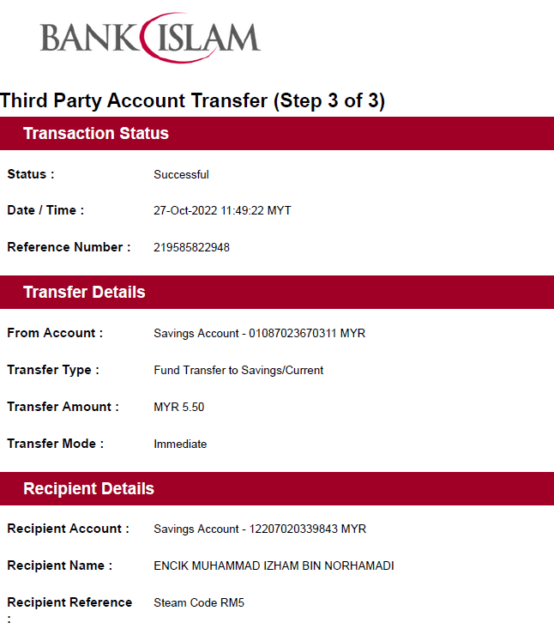

## Sales Summary Table

|  |  |  |  |  |  |  |  |
| --- | --- | --- | --- | --- | --- | --- | --- |
| No. | Customer Name | Address | Payment Method | Deliver Method | Date of Purchase | Amount (RM) | Total (RM) |
| 1 | Affendy Elyas | DT328, Jalan Bukit Tambun Perdana 6, Taman Bukit Tambun Perdana | Online payment (Bank Islam) | Self-deliver | 26/10/2022 | i) Steam Code: 20.00 ii) Service cost: 0.50 | 20.50 |
| 2 | Aliff | DT328, Jalan Bukit Tambun Perdana 6, Taman Bukit Tambun Perdana | Online payment (Maybank) | Self-deliver | 26/10/2022 | i) Steam Code: 30.00 ii) Service cost: 0.50 | 30.50 |
| 3 | Affendy Elyas | DT328, Jalan Bukit Tambun Perdana 6, Taman Bukit Tambun Perdana | Online payment (Bank Islam) | Self-deliver | 27/10/2022 | i) Steam Code: 5.00 ii) Service cost: 0.50 | 5.50 |
| 4 | Ahmad Sha | DT317, Jalan Bukit Tambun Perdana 6, Taman Bukit Tambun Perdana | TnG Wallet | Self-deliver | 15/11/2022 | i) Steam Code: 10.00 ii) Service cost: 0.50 | 10.50 |

## Go-eCommerce Report

1. Personal Information

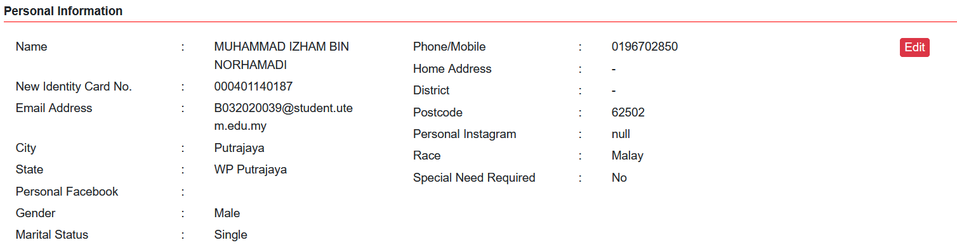

1. Business Profile

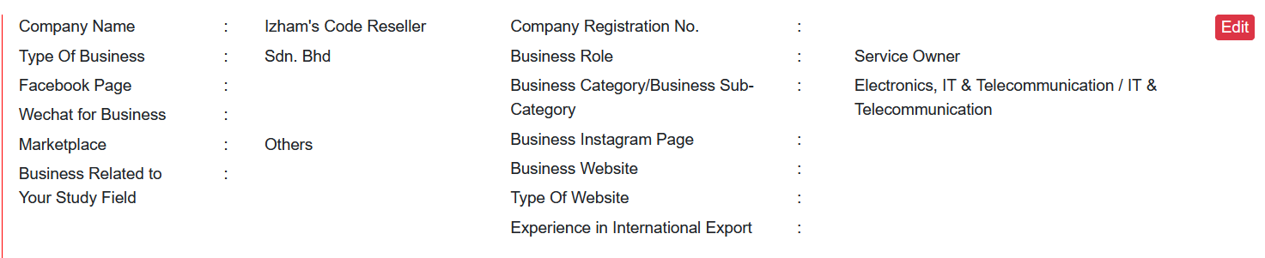

1. Transaction Record

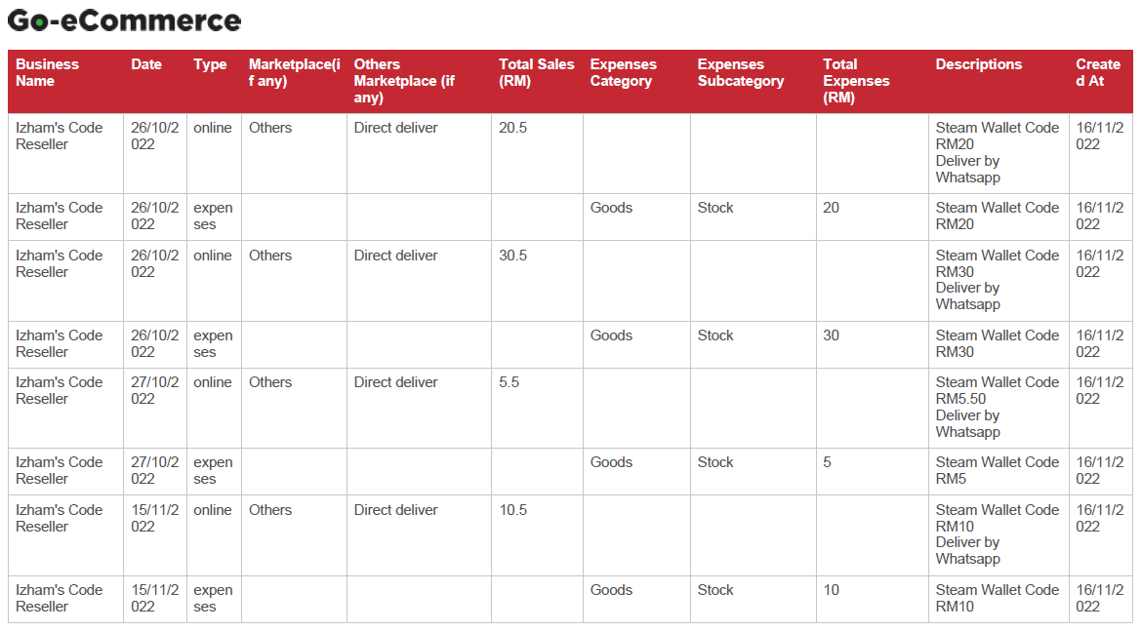

## Sales Report (Go-eCommerce)

